PHOTOGRAPHING BELUGA WHALES FOR IDENTIFICATION

CIBW PHOTO-ID PROJECT PROTOCOL

Updated August 2017

The Cook Inlet Beluga Whale Photo-ID Project:

Photo-ID provides information about individual Cook Inlet beluga whales (CIBWs) and the population as a whole, including residency/movement patterns, habitat use, reproduction, and survival. Over thirteen field seasons (2005-2017) the CIBW Photo-ID Project has developed a photo-catalog containing digital images of approximately 375 individual CIBWs possessing distinct natural markings that persist over time. Many photographs of these CIBW display marks indicative of disease and injury. By documenting the occurrence and frequency of these marks and attempting to identify mark sources, we can learn more about disease and injury affecting the endangered CIBW population. We also photograph beluga mortalities in order to note those previously identified whales in the catalog that have died, and also to examine possible cause of death. Continued collaboration throughout Cook Inlet increases the photographic documentation and examination of disease, injury, and mortality of Cook Inlet beluga whales.

How can you help?

If you happen to encounter any CIBWs, either free-swimming or stranded and you take photographs we would love to see them! All photographs contributed to the CIBW Photo-ID Project go to help better understand these endangered whales. We will let you know about any whale we recognize and you will get full credit for any of your photographs used in our catalog and acknowledged in our reports. But more importantly will you will be helping with research. We have put together some tips and recommendations on the best way to photograph them to be compatible with the CIBW Photo-ID Project protocols. While these are our recommendations for the best photos, we will happily accept any photos of CIBWs taken. It only takes one photo to add missing pieces to the puzzle!

Even if you don’t have photographs, we want to hear about your sightings. All free-swimming whale sightings can be reported at www.cookinletbelugas.com .We are interested in knowing:

- Date and time belugas were seen
- Location of whales (lat long or mile markers helpful)
- How many belugas did you see? (# of white whales, # of gray whales and # of calves)
- What were they doing? (traveling, feeding, resting etc.)
- Your name and contact information
- Can we use your name and sighting information on our sightings map?
All stranded whales should be reported to the Alaska Marine Mammal Stranding Network at (877) 925-7773.

What we’re looking for:

- Photos (digital preferred) of Cook Inlet belugas (dead or alive)
- High resolution images (RAW or fine JPEG)
- Enough light to view contrast
- Minimal glare
- Photos taken at 90o angle to marks or wounds
- Photographs of:
  - the entire whale (entire surfacing sequence in water or entire whale on a stranded animal)
  - the dorsal ridge and side(s) (When we photograph live CIBWs, we rarely see the head and tail region of the whale, therefore most of the whales in the catalog are identified by marks along the dorsal and side regions), and
  - the lower abdomen (to determine sex of whale, mostly just stranded whales)
- Zoomed-in photos of marks (stranded whales)
  - For dead whales, include scale in photograph (can be a ruler, coin, pencil, hand, boot, etc.) to indicate the size of the mark or wound being photographed
- Information on whether the photograph is of the left or right side of the whale (if known)
- Time/date stamp- make sure camera settings are accurate, or note correct date/time when submitting the photos
- Information about where the photo was taken (location and lat/long coordinates if possible, mile marker along the Seward Highway)
- Photographer name (for credits)

Things to avoid when taking a photo:

- Glare washes out parts of the photo, making it hard to distinguish between marks and skin
- Lack of scale prevents us from determining the dimensions of marks or wounds
- Low resolution images become blurry when zoomed in
- Angled photos make it hard to compare marks from photos taken at different angles. Profile shots of the sides of the whale focused around the dorsal ridge are best.
- Obstructions of marks or wounds – mud, sand, and/or blood may collect in marks. Use water to rinse the area before photographing it, if possible. Bring a bucket or something to transport water to rinse the skin of a dead whale. Do not otherwise touch or move a live or dead stranded beluga, it’s against the law!

Examples of photos that are useable for the Photo-ID Project (free-swimming whales):

Example of an entire surfacing sequence taken at the correct angle to the whale. By taking a full surfacing sequence of shots, we can see that this whale has a calf accompanying it. Photos taken under General Authorization, Letter of Confirmation No. 481-1759, MMPA/ESA Research Permit #14210 and #18016 . Do not reproduce without permission.
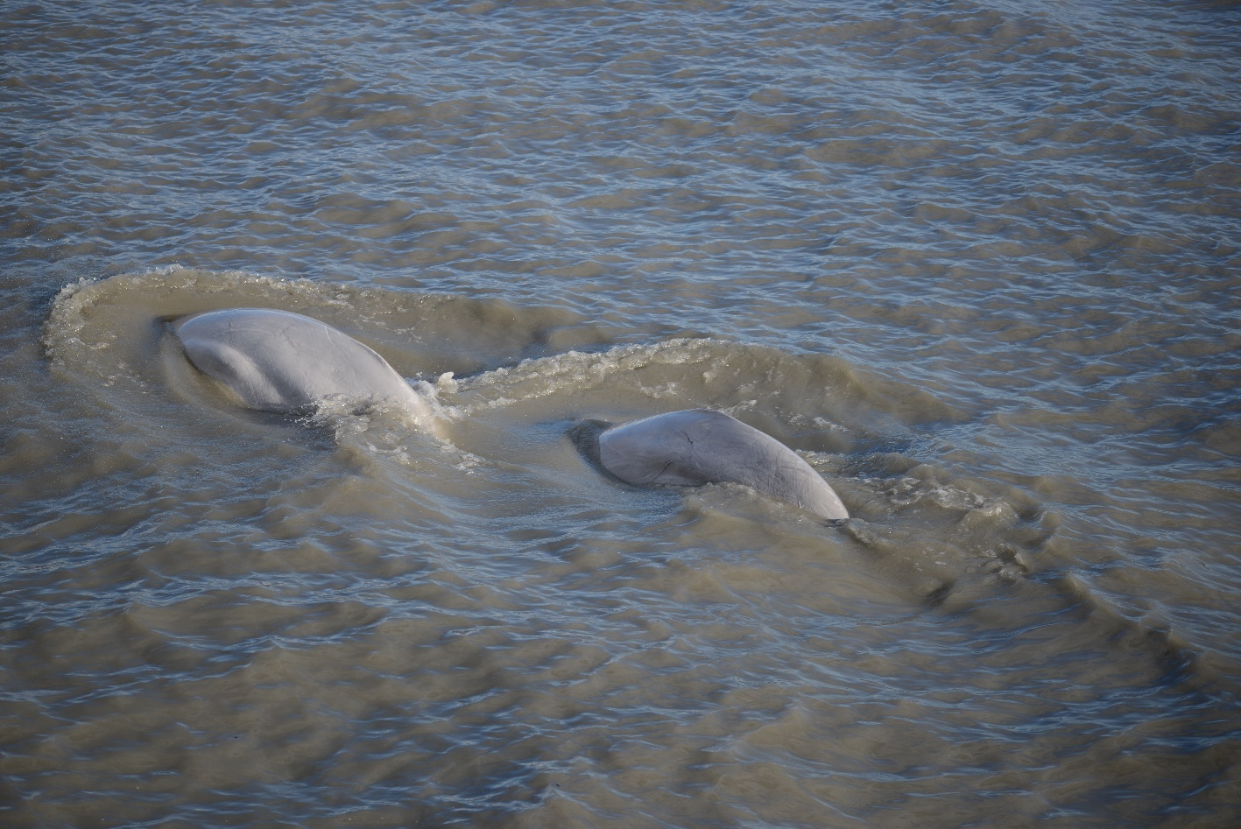
Example of a photo taken of free-swimming whales along Turnagain Arm. This photo is taken at the appropriate angle were the sides of the belugas are seen as well as the dorsal ridge area. Photos taken under General Authorization, Letter of Confirmation No. 481-1759, MMPA/ESA Research Permit #14210 and #18016 . Do not reproduce without permission.

Examples of photos that are useable for the Photo-ID Project (stranded whales):
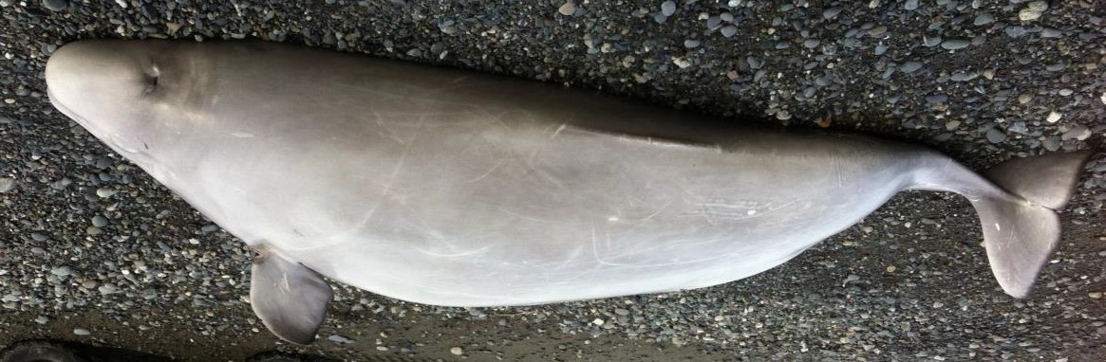
This is an excellent photograph in which you can see the entire whale; there is low glare so the marks really show. You can see the side of the whale as well as the dorsal ridge. Photograph courtesy of NMFS.
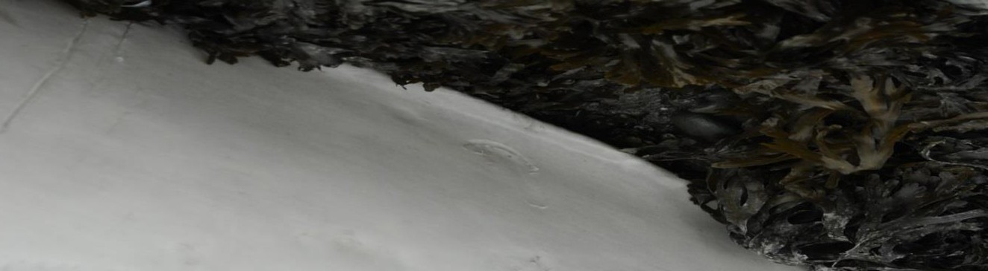
This is an example of what can be gained by removing an obstruction. The dorsal ridge of this whale was originally covered by rockweed. This whale was identified by the mark that couldn’t be seen until it was uncovered. This photo is lacking in scale and information about what side of the whale is being photographed, but is still useable.

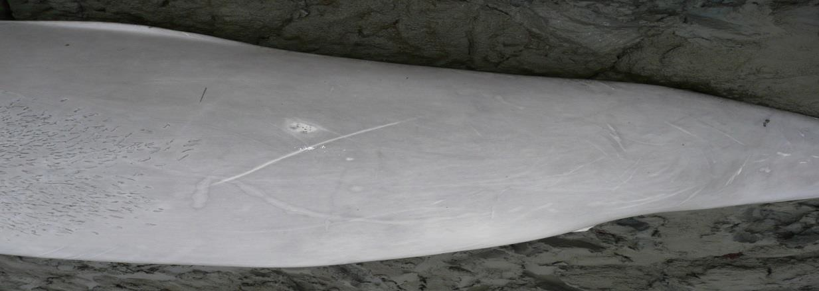
This photo is taken at a 90-degree angle, it is in focus and you can clearly see the marks.

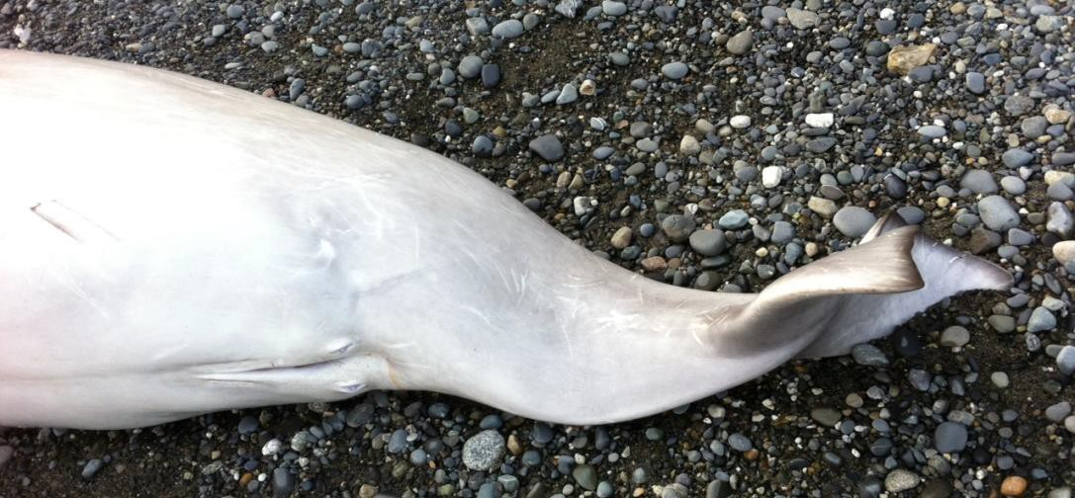
This photo is a good example of an abdomen shot that helps us determine the sex of the whale. We need this along with a dorsal ridge photo to id the whale. Photograph courtesy of NMFS.

Examples of photographs that are not useable for the Photo-ID Project:

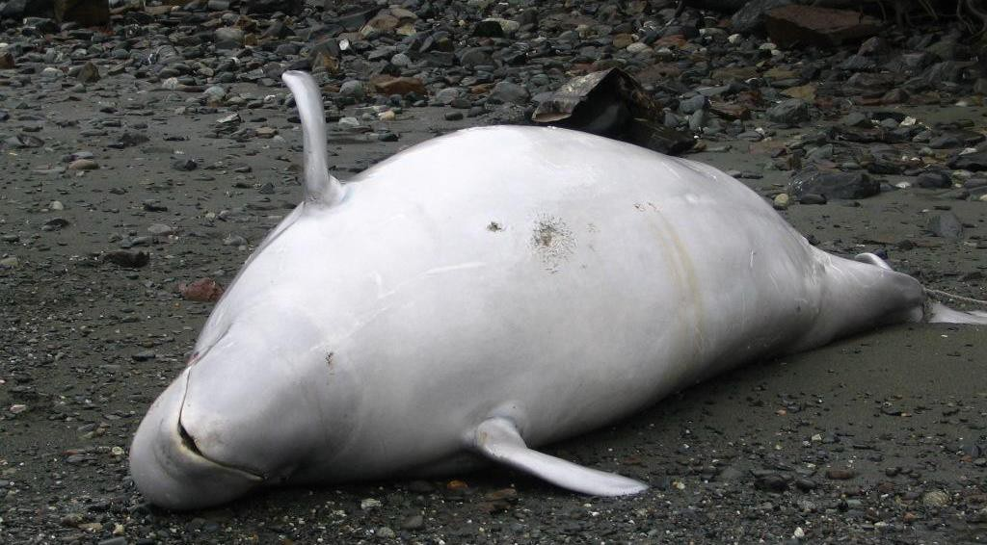

While this photo is in focus and you can see some marks, the Photo-ID Project cannot identify a whale from marks on the abdomen. In addition, this photo is taken at an oblique angle and we cannot determine the sex of the whale from this angle.

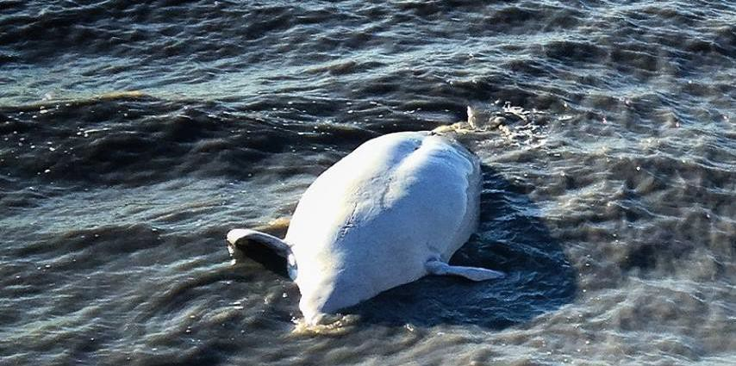
This photo is not useable because it is a little out of focus and it only shows the ventral side of the whale.
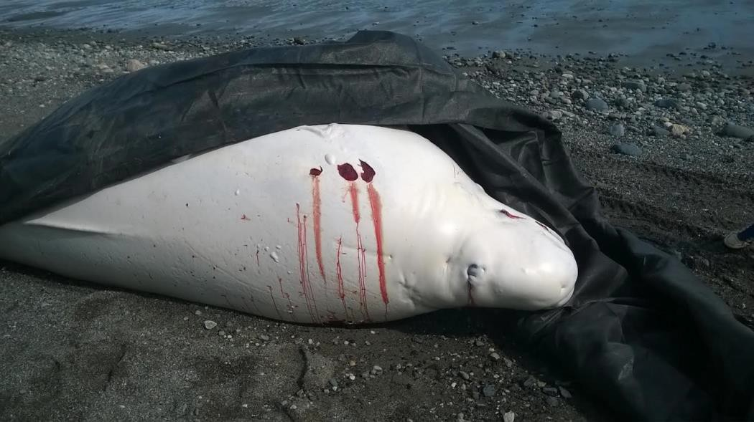

This photograph is a good example of the proper angle and distance from the whale; however, it is unusable for photo-id. While some marks can be seen, the important parts of the body for identification (i.e., the side and dorsal ridge) are unfortunately covered up and most of the whale cannot be seen. Photograph courtesy of NMFS.

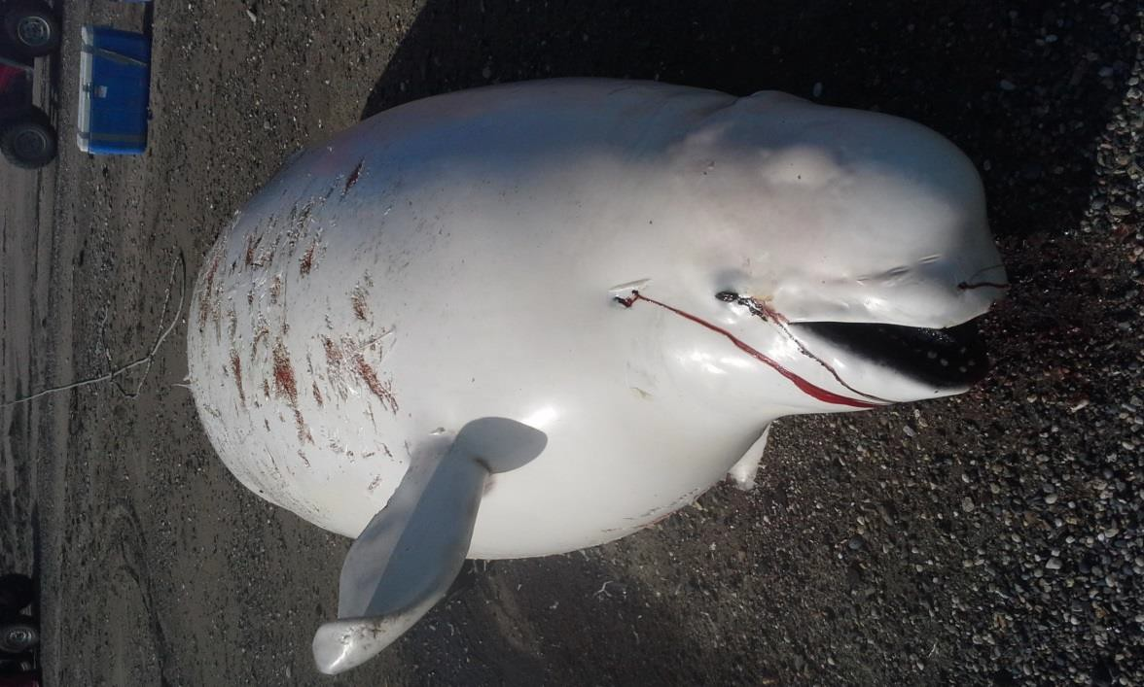
This photo is also in great focus and the proper distance from the whale, but it is taken at an angle and most of the body is out of sight, so it is unusable for photo-id. Photograph courtesy of NMFS.

